**# EYE-BLINK-DETECTION**

Eye Blink Detection or Liveliness detection [ through Facial Landmarks and OpenCv ]

​

We are using Python, OpenCV, and dlib code to:

(1) perform facial landmark detection and

(2) detect blinks in video streams(from Videofiles or Live Webcam)

​

**Understanding the “eye aspect ratio” (EAR):**

we can apply facial landmark detection to localize important regions of the face, including eyes, eyebrows, nose, ears, and mouth. This also implies that we can extract specific facial structures by knowing the indexes of the particular face parts.In terms of blink detection, we are only interested in two sets of facial structures — the eyes.

Each eye is represented by 6 (x, y)-coordinates, starting at the left-corner of the eye (as if you were looking at the person), and then working clockwise around the remainder of the region.

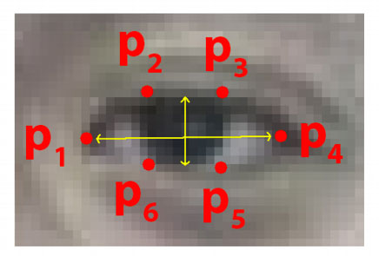

The 6 facial landmarks associated with the eye.

**There is a relation between the width and the height of these coordinates.**

Based on the work by Soukupová and Čech in their 2016 paper, [***Real-Time Eye Blink Detection using Facial Landmarks***](http://vision.fe.uni-lj.si/cvww2016/proceedings/papers/05.pdf), we can then derive an equation that reflects this relation called the eye aspect ratio (EAR):

The Eye aspect ratio equation:

EAR = (||P2 – P6|| + ||P3 – P5||) / 2(||P1 – P4||)

Where p1, …, p6 are 2D facial landmark locations.

The numerator of this equation computes the distance between the vertical eye landmarks while the denominator computes the distance between horizontal eye landmarks, weighting the denominator appropriately since there is only one set of horizontal points but two sets of vertical points.

Why is this equation so interesting?

Well, as we’ll find out, the eye aspect ratio is approximately constant while the eye is open, but will rapidly fall to zero when a blink is taking place.

Using this simple equation, we can avoid image processing techniques and simply rely on the ratio of eye landmark distances to determine if a person is blinking.

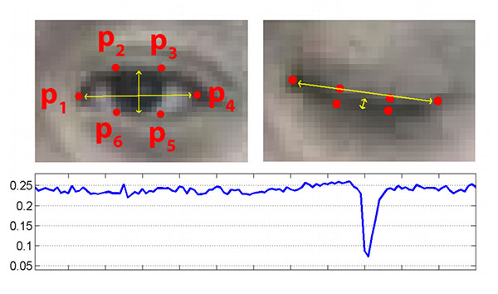**Figure 5:** *Top-left:* A visualization of eye landmarks when then the eye is open. *Top-right:* Eye landmarks when the eye is closed. *Bottom:* Plotting the eye aspect ratio over time. The dip in the eye aspect ratio indicates a blink (Figure 1 of Soukupová and Čech).

On the *top-left* we have an eye that is fully open — the eye aspect ratio here would be large(r) and relatively constant over time.

However, once the person blinks (*top-right*) the eye aspect ratio decreases dramatically, approaching zero.

The *bottom* figure plots a graph of the eye aspect ratio over time for a video clip. As we can see, the eye aspect ratio is constant, then rapidly drops close to zero, then increases again, indicating a single blink has taken place.

The eye aspect ratio is instead a much more elegant solution that involves a very simple calculation based on the ratio of distances between facial landmarks of the eyes.

This method for eye blink detection is fast, efficient, and easy to implement.